**National Science Week (SA)**

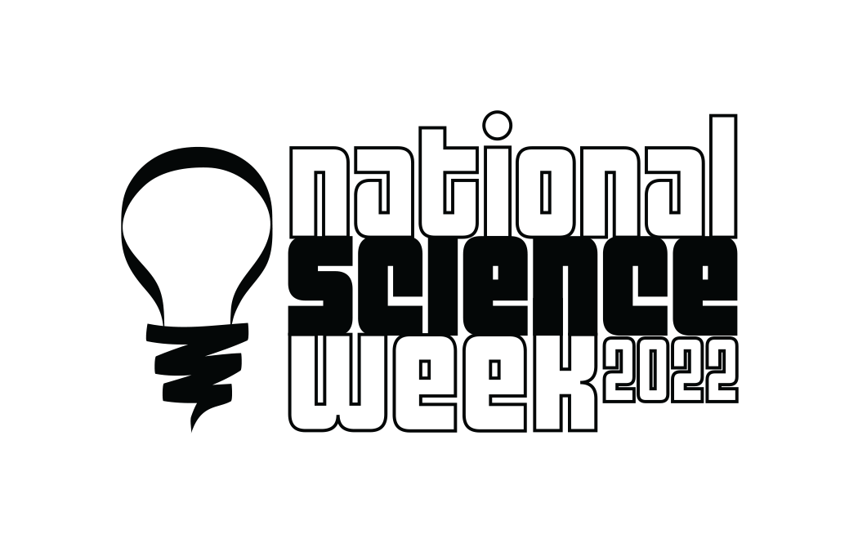

UNSUNG HERO AWARDS OF

SOUTH AUSTRALIAN SCIENCE

Nominations are now open for the **2022 Unsung Hero Awards of South Australian Science**.

The **Unsung Hero Awards of South Australian Science** are administered by National Science Week SA.

There are 2 awards offered:

1. **Unsung Hero of South Australian Science** - for science and research endeavours
2. **Unsung Hero of South Australian Science Communication** - for the communication of science

The awards are intended to recognise those whose contribution has been significant over a long period of time but who have not yet received formal public recognition.

**Criteria**

*Please read the criteria for each award carefully to ensure that nominations are made for the appropriate award.*

**Unsung Hero of South Australian Science**

The criteria for nomination for the **UNSUNG HERO OF SOUTH AUSTRALIAN SCIENCE** are as follows:

1. ***Nominees*** must reside in South Australia, actively engage in science research, scientific methodology or practice, and have made a significant contribution to and impact on the scientific life of South Australia. While nominees should have shown respect for science communication, this award recognises science practitioners in areas other than teaching and communication.

Those whose strengths lie in these latter areas might be suitable nominees for the award of UNSUNG HERO OF SOUTH AUSTRALIAN SCIENCE COMMUNICATION.

1. The work for which the nominee is being nominated must have been carried out in South Australia or, if of national significance, should have considerable relevance to South Australia.
2. The nominee should be a person or persons who have not yet received significant recognition for their contribution to science. The following are ineligible for this award:
   1. Well known or popular scientists
   2. Professors
   3. Winners of major state, national or international science awards
   4. Principal or chief investigators on Category 1 national academic grants during the past ten years
   5. Recipients of ARC awards
   6. Recipients of Order of Australia or similar awards
3. Nominees should have a considerable or prolonged record in science.

The award is intended to recognise those whose contribution has been significant over a long period of time but who have not yet received formal public recognition. It is unlikely that this would apply to a candidate whose contribution, however significant, is of short duration.

1. Nominators must give careful consideration to what counts as ‘science’ - for example, nominees from technological or environmental fields should be nominated not just on the basis of their contribution to those particular fields, but ***because the scientific side***of their work is strong.

**Notes:**

This award may be made to a candidate whose work is in science or in a number of related fields (e.g. technology, environment, health etc) where the ***science component*** of their work is highly significant.

**----------------------------------------------------------------------------------------------------------------------------------------------------------**

**Unsung Hero of South Australian Science Communication**

This award is a companion to the UNSUNG HERO OF SOUTH AUSTRALIAN SCIENCE, and honours a person or persons who exemplify science communication.

The criteria for nomination for the **UNSUNG HERO OF SOUTH AUSTRALIAN SCIENCE COMMUNICATION** are as follows:

1. ***Nominees*** must be resident in South Australia and actively engaged in science communication, interpreted broadly to include, but not limited to, pursuits such as:

* teaching
* traditional and/or social media
* script and book writing
* public presentations
* interpretation of science within cultural institutions

Those whose strengths lie in other areas such as science research or practice may be suitable nominees for the UNSUNG HERO OF SOUTH AUSTRALIAN SCIENCE award.

1. The work for which the nominee is being nominated must have been carried out in South Australia or, if of national significance, it should have considerable relevance to South Australia.
2. The nominee should be a person or persons who have not yet received significant recognition for their contribution to science communication. The nominee should have shown that their science communication outcomes are underpinned by the best possible science. The following are ineligible for this award:
   1. Professors
   2. Winners of major state, national or international science communication awards
   3. Recipients of Order of Australia or similar awards

1. Nominees should have a considerable or prolonged record in science communication.

The award is intended to recognise those whose contribution has been significant over a long period of time but who have not yet received formal public recognition. It is unlikely that this would apply to a candidate whose contribution, however significant, is of short duration.

1. Nominators must give careful consideration to what counts as ‘science’ - for example, nominees from technological or environmental fields should be nominated not just on the basis of their contribution to those particular fields, but because the scientific side of their work is strong and their communication contributes to a better understanding of the process and practice of science.

**Notes:**

This award may be made to a candidate whose work is specifically in science education, promotion or communication in one or many fields where the ***science component*** of their work is highly significant. Preference will be given to nominees who deliver science communication in addition to their core role. Individuals professionally employed as Science Communicators are ineligible.

**Benefits of Awards**

Ideally, the award may assist the recipient in their work, for example by publicising a difficult issue, or to focus attention on their efforts, or give their work greater credibility.

**Selection Process**

Selection is based primarily on the written information provided on the nomination form, but referees may be contacted for additional information.

A selection committee will assess all nominations and determine award recipients.

In some instances the selection committee may seek further information before making their final decision.

**Award Nominations**

**Requirements for Award Nomination**

The nominator needs to consult with the referees, but it is not essential that the nominee is made aware of the application.

Each nomination must comprise a fully completed award nomination form. Preferable length: 2 pages.

**Nominations close at 5pm on Friday 3 June 2022.**

The winners will be announced at a special function to be held at a date to be determined.

**Nomination enquiries to**

Ms Rona Sakko on 0419 827 723

**Email completed nominations to**

Ms Rona Sakko, Chair - National Science Week SA Coordinating Committee

E-mail: rona.sakko@gmail.com

**Further information about National Science Week:** [www.scienceweek.net.au](http://www.scienceweek.net.au)

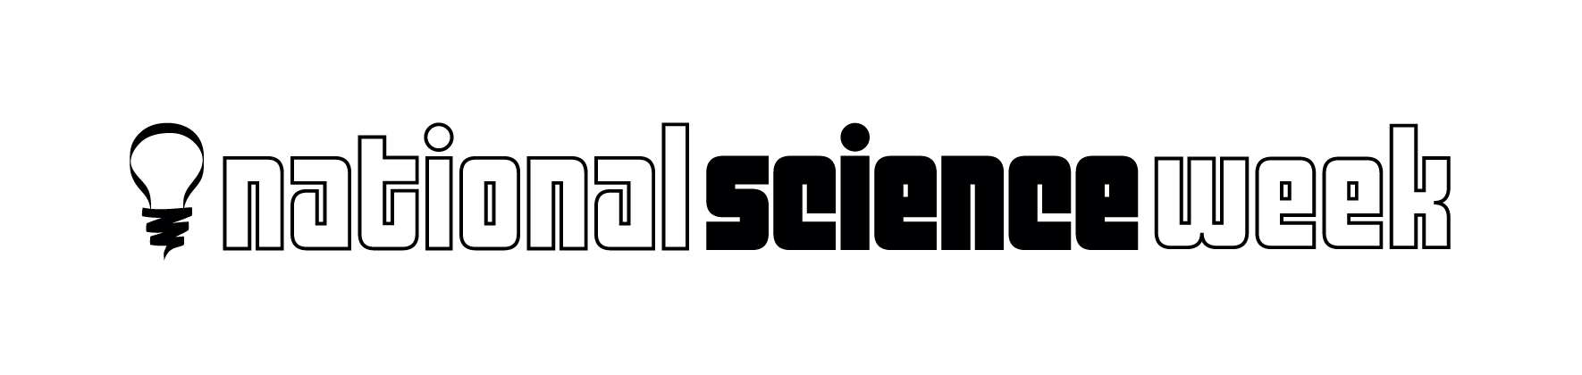

UNSUNG HERO AWARDS OF

SOUTH AUSTRALIAN SCIENCE

**NOMINATION FORM 2022**

**Nominee Details**

Name:

Organisation:

Address:

Phone:

Email:

**Nominator Details:**

Name:

Organisation:

Address:

Phone:

Email:

**Nominating for the Award of:**

❑ **Unsung Hero of South Australian Science**

❑ **Unsung Hero of South Australian Science Communication**

**Reasons for Nomination:** (Max. of 2 pages)

(Note: Depending on the award, include details such as scientific achievements, length of time in science field, and current work and research **or** achievements and work in science communication and length of time in this area)

**Support Information**

List and describe any previous awards or recognition the nominee has received for their work in the science or science communication field

**Referees**

The following people are familiar with the work of the nominee and will referee my nomination.

**Name:**

**Organisation:**

**Address:**

**Telephone:**

**Email:**

**Name:**

**Organisation:**

**Address:**

**Telephone:**

**Email:**

**Nominations will close at 5pm on Friday 3 June 2022.**