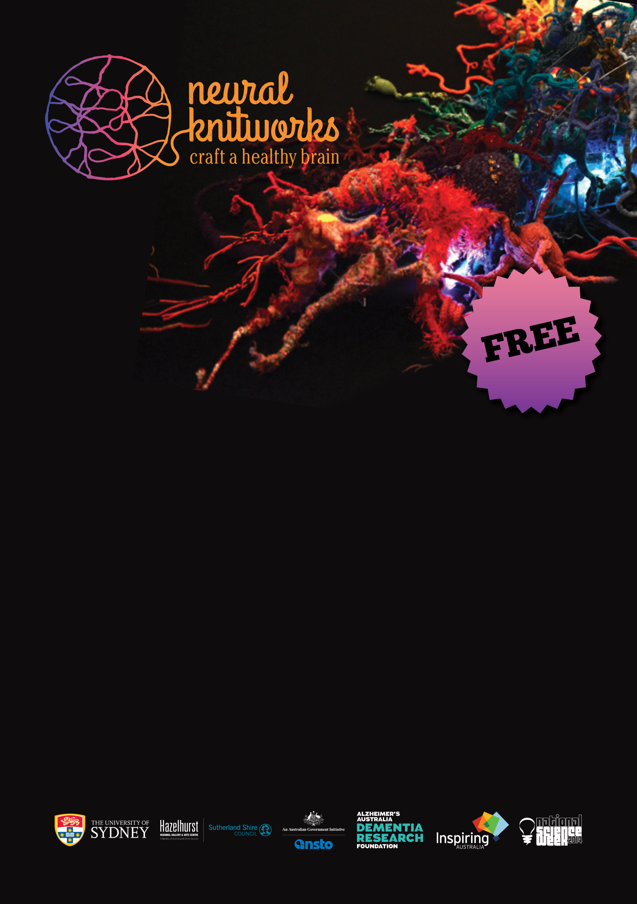

Neural Knitworks is a collaborative art/science project about mind and brain health. Whether you’re a whiz with yarn, or just discovering the joy of craft, now you can crochet, wrap, knit or knot – and find out about neuroscience! Your creations will join others on-line to weave a virtual knitted ‘neural network’.

*Include a short description of your event here and a call to action.*

**Enquiries:** Include a phone number and email so the public can get in touch and possibly donate materials.

Visit [**www.scienceweek.net.au**](http://www.scienceweek.net.au) for more information.

**Location of your event**

**Date and time of your event**